**CHAPTER 6**

**SYSTEM DESIGN**

**6.1 DATA FLOW DIAGRAM**

**6.1.1 Use Case Diagram**

A use case diagram is a way to summarize details of a system and the users within that system. It is generally shown as a graphic depiction of interactions among different elements in a system. Use case diagrams will specify the events in a system and how those events flow, however, use case diagram does not describe how those events are implemented. A use case is a methodology used in system analysis to identify, clarify, and organize system requirements. Use case diagrams have only 4 major elements: The actors that the system you are describing interacts with, the system itself, the use cases, or services, that the system knows how to perform, and the lines that represent relationships between these elements.

Use case diagram shows a set of use actor and relationship as shown in figure 6.1. A use case diagram contains actors, use cases and interactions or relationships. Use case diagram can be used during analysis to capture the system requirement and to understand how the system should work. A use case is a description of how a person who actually uses that process or system will accomplish a goal. It's typically associated with software systems, but can be used in reference to any process. A description of system behaviour in terms of sequence of action is called use case. A use case should yield an observable result of value to an actor. A use case contains all alternative flows of event related to producing the “observable of result value”.

**Data set**

Water Control board

Collect Water Det

WQP Model

Train machine learning model

**Result**

Evaluate Machine Learning model

Deploy machine learning model

Water Quality Prediction

**6.1.2 Flow Diagram**

It is a step-by-step action taking places process. It is an interaction diagram that emphasis time ordering of messages. It shows the object participating in the interaction by their “Life lines” and the message that they send to each other.

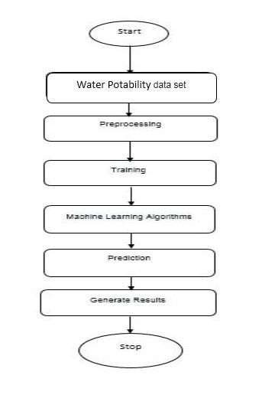

Fig

**6.2 MODULE DESCRIPTION**

**6.2.1 IoT Sensor Module**

An IoT (Internet of Things) sensor module is a small electronic device that is designed to detect and transmit data about physical phenomena to a central system or network. These modules are typically equipped with sensors that can detect things like temperature, humidity, light, motion, and more, and they can be configured to communicate with a wide range of other devices and systems over a wireless network. IoT sensor modules play a key role in enabling the collection of real-time data from a variety of sources, which can be used to inform decision-making and improve efficiency in a wide range of industries, from manufacturing and logistics to healthcare and smart home automation. With the proliferation of IoT technology, sensor modules are becoming increasingly sophisticated and versatile, offering greater accuracy, longer battery life, and more advanced features like machine learning and edge computing capabilities. IoT sensor modules can be used for a variety of applications, such as environmental monitoring, asset tracking, predictive maintenance, and even predictive healthcare. They can also be integrated into larger IoT ecosystems, such as smart cities or industrial automation systems, to enable real-time monitoring and control of a wide range of devices and processes. As the demand for IoT technology continues to grow, IoT sensor modules are expected to become even more ubiquitous and essential to our daily lives.

**6.2.2 Data Collection and Management Module**

This module would be responsible for collecting and managing the data generated by the IoT sensors. It would include a data storage and management system to store the data, and an API to enable integration with other modules and external systems.

**6.2.3 Machine Learning Model Development Module**

This module would be responsible for collecting and managing the data generated by the IoT sensors. It would include a data storage and management system to store the data, and an API to enable integration with other modules and external systems.

**6.2.4 Predictive Maintenance Module**

This module would use the data from the IoT sensors and the trained machine learning models to predict when equipment maintenance is needed. This would include developing appropriate algorithms to predict equipment failures based on historical data, and generating alerts or work orders when maintenance is predicted.

**6.2.5 Visualization and Reporting Module**

This module would be responsible for visualizing the water quality data and providing reports to operators and stakeholders. This would include creating dashboards to display real-time data, generating reports on water quality trends and anomalies, and providing alerts and notifications to stakeholders as needed.